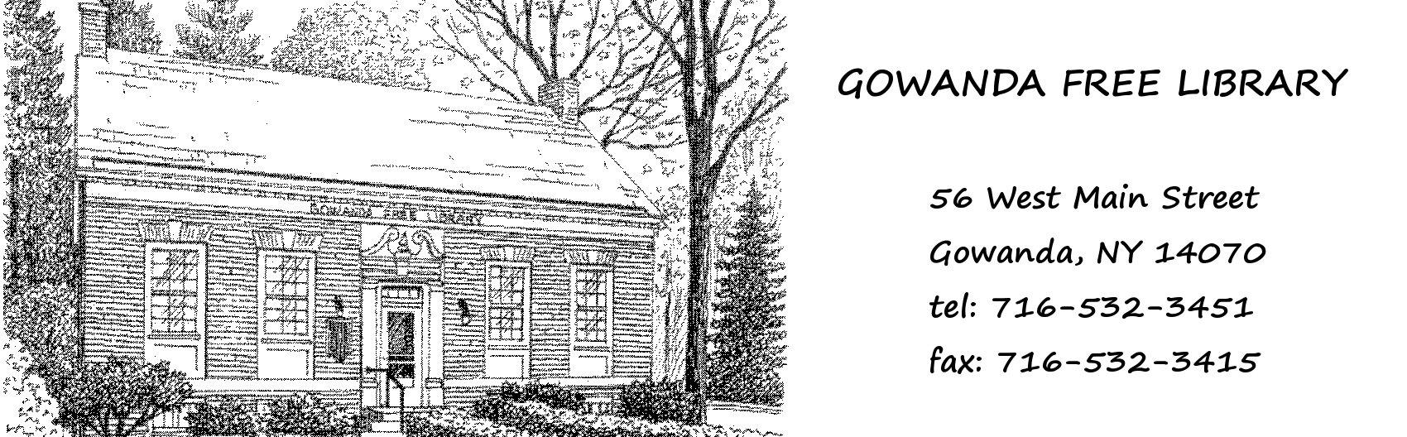
Gowanda Free Library
56 West Main St.
Gowanda, NY 14070
Ph (716) 532-3451
Fax (716) 532-3415
gowandalibrary.org

Application for Employment
1. Personal Information
Name: ______________________________________________________________________
Address: ____________________________________________________________________
Phone number: _____________________Email: ____________________________________
Position applied for__________________________________
Age: (only if under 18) ____ (If you are under 18 be aware you will need to obtain working papers)
If under 18, list school you are attending: _________________________________
What is the last grade you have completed: __________________________________
Date available: ________________
Date of this application: ____________________________
Are you legally authorized to work in the United States? _________________

2. Availability
(Please write the hours you are available each day)
Mon: _______________________ Tues: ____________________Wed: ______________________
Thurs: _______________________Fri: _______________________Sat: _____________________

3. Education
How many years of high school have you completed? __________________
Where? _______________________________
Did you graduate? __________
How many years of undergraduate college have you completed? ________________
Where? ______________________________________
Degree(s) & major(s) _______________________________________________________________
Have you completed any graduate work? _______________
If so, please give details: ________________________________________________________________________________
Do you have other formal education or certifications? (E.g., Business school, vocational school, etc) ________________________________________________________________________________________________________________________________________________________________

4. Employment History
(Fill out if not all of the below information is reflected on your resume)

Employer Name: ________________________________________________________________________________
Job Title/Description: ________________________________________________________________________________
Dates: ______________________________________________Phone: ______________________
Employer Name: ________________________________________________________________________________
Job Title/Description: ________________________________________________________________________________
Dates: ______________________________________________Phone: ______________________
Employer Name: ________________________________________________________________________________
Job Title/Description: ________________________________________________________________________________
Dates: ______________________________________________Phone: ______________________

5. Special Skills
Do you have any computer experience? ________
If so, please specify skills and programs ________________________________________________________________________________________________________________________________________________________________________________________________________________________________________________

Other skills and experience that would assist in your job functions:
________________________________________________________________________________________________________________________________________________________________________________________________________________________________________________

6. Why would you like to work in the library?
Briefly explain what you think would make you a good fit for the library
________________________________________________________________________________________________________________________________________________________________________________________________________________________________________________

7. References
Please list up to three persons whom we may contact to provide references for you. Two can be personal references, and at least one should be a former employer if applicable. Refrain from listing family members if possible.

- Name: _____________________________________________________________________
Address: ___________________________________________________________________
Relation: ________________________________Phone______________________________

- Name: _____________________________________________________________________
Address: ___________________________________________________________________
Relation: ________________________________Phone______________________________

- Name: _____________________________________________________________________
Address: ___________________________________________________________________
Relation: ________________________________Phone______________________________

The Gowanda Free Library is an Equal Opportunity employer: employment and job classification are without regard to race, religion, gender, gender identity, sexual orientation, national origin, disability or age. Furthermore, Gowanda Free Library is an at-will employer.

If you have any questions regarding this job, or about the application, please contact Director- Hayley Wilkins via email at director@gowandalibrary.org or phone 716-532-3451

